Muhammad Faiz Bin Kamaruddin

1500826A

**Question 1**

Software development life cycle (SDLC) could be defined as the process for planning, creating, testing and deploying of the software system or the timeline of processes of the software system from the start to the end of the development.

There are 5 phases in the Software Development Life cycle. Firstly, the Requirements engineering where It is a phase to identify the needs and requirements a customer or client would like to have in a software or what the software has to do, which is the most important process of the software development phase. Secondly, the Analysis and Design phase, using text and diagrams to explain the software requirements, and producing an entity representation that will be built in future such as the user interface design. Thirdly, the Implementation phase or Coding phase, it is where the detailed designs will be used as instructions that will be written in programming languages. Fourthly, the Testing Phase, customers or other users will test the software to ensure if its reliable and it meets their needs. Finally, the Deployment and the Maintenance phase, the software will be officially released and distributed to a group of selected customers where it might require training to be able to use them.

Software development models such as Waterfall model, Prototyping and Agile methods.

Waterfall model is a sequential design process where each of the processes has to be completed before moving on to the next process. It starts off with the Requirements moving to Analysis/Design to Coding/Implementation and to the Testing and finally the deployment stage. The Waterfall model has advantages such as maintaining more control of the tasks since its being divided, each task completed is well documented and monitoring the tasks done is much easier to maintain and control performing a single activity at a time.

However, it has disadvantages such as unable to revert back the changes of previous steps when it has been done and unable to validate the users requirements at early development stages.

Working Concept:

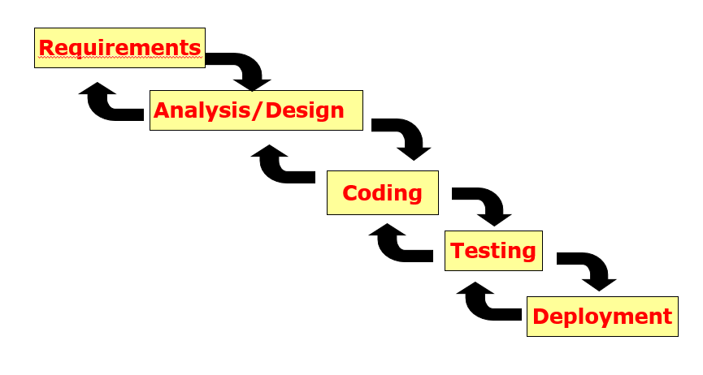

Prototyping is split between 2 prototyping approaches, Throwaway Prototyping and Evolutionary Prototyping. Throwaway Prototyping creates a prototype of a software with initial specifications containing some requirements which are poorly understood which is being showed to the clients and a full specification is being written before the prototype is being thrown. Based on the full specification written, a full-scale system will be built.

Prototyping has advantages such as being able to understand and clarify the requirements of its users and being able develop its specifications slowly which allows the users and customers to have time to change their minds or to improve the specifications

However, it has disadvantages such as difficulty in estimating, planning and managing the prototype as customers and users may choose to improve or alter the specifications at any point of time. It also causes frequent corruption of the software structure which are more costly and difficult to handle.

Throwaway Prototyping has techniques such as being able to ignore error handling, ignoring functions and making use of high-level languages.

Working Concept:

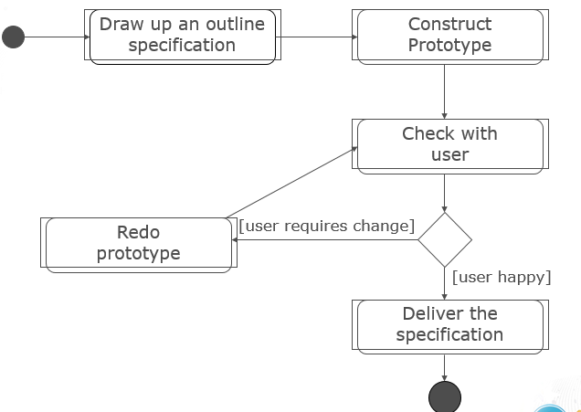

Evolutionary Prototyping develops an initial system by implementing parts that are well understood. This developed system will be constantly shown to the users for their opinions which could be used to improve the system. This process will be repeated to refine the system and implement more parts till its completed.

Working Concept:

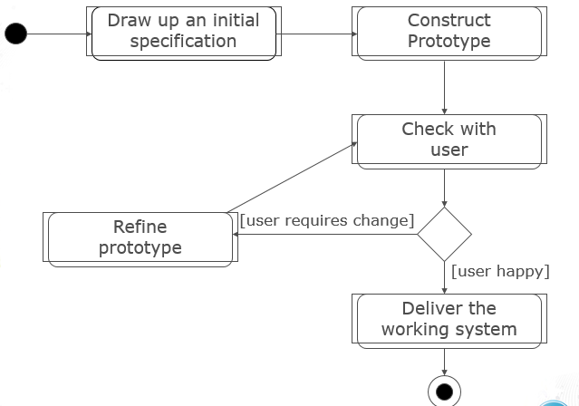

Agile Method or Agile Modelling is a combination of incremental and iterative process focusing on system adaptability and customer satisfaction. This method produces products or systems which are potentially shippable after every iteration or sprints. It usually breaks down the product or system into smaller incremental builds. It also makes use of SCRUM as an implementation.

Agile has advantages of delivering working software in short durations of time, able to make changes for requirements even though how late it is in development this includes the adaptation to different and changing expectations.

However, it has disadvantages such as lack of emphasis on the designing and its documentation. It is also easier to lose track of the purpose or get out of point if there are no proper understanding of the customer’s outcome.

Working concept:

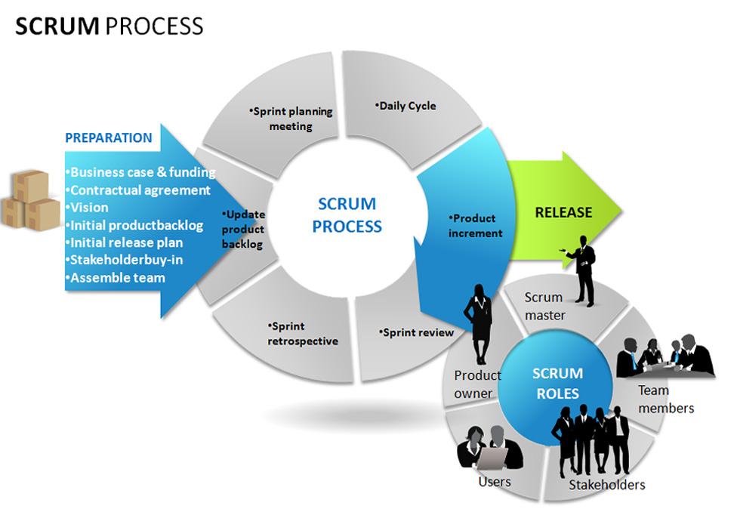

References:

<http://istqbexamcertification.com/what-is-agile-model-advantages-disadvantages-and-when-to-use-it/>

<https://www.techopedia.com/definition/22193/software-development-life-cycle-sdlc>

<http://istqbexamcertification.com/what-is-waterfall-model-advantages-disadvantages-and-when-to-use-it/>

<http://www.agilemodeling.com/essays/introductionToAM.htm>

<https://www.google.com.sg/search?q=agile+model&oq=agile+model&aqs=chrome..69i57j69i59l2j0l3.7816j0j7&sourceid=chrome&ie=UTF-8>

http://www.drdobbs.com/architecture-and-design/sdlc-sdlc-models-advantages-disadvantag/228701074

<https://www.cprime.com/wp-content/static/images/resources/ScrumOverviewResized.jpg?ca3ce9>

*Some resources are being used from the PowerPoint slides from lms.tp.edu.sg